Mahadevan VS
Mahadevan.vs@mphasis.com
Abstract
This document presents an AI-powered supply chain architecture to handle extreme inventory volatility during Black Friday sales. It integrates predictive demand modeling, real-time inventory tracking, and automated replenishment workflows to minimize stockouts, fulfillment errors, and last-mile inefficiencies.
AI-Powered Supply Chain Architecture – Black Friday Inventory Volatility

Table of Contents
Business Challenge & Context 1
Functional Requirements 1
Non-Functional Requirements (NFRs) 2
Architecture Overview (Solution Strategy & Building Blocks) 2
Key Layers & Components 3
AI & Automation Integration 3
Solution Flow Diagram 4
Runtime View (Scenario: Real-Time Replenishment Flow) 4
Risks and Mitigations 5
Architecture Decision Records (ADRs) 5
Conclusion 5

Business Challenge & Context
During Black Friday, the company experiences 15× demand variability, with over 200,000 SKUs across multiple warehouses and distribution hubs. Manual tracking and decision-making create 15–20% fulfillment errors and delayed replenishments.
The solution must enable:
- Real-time supply chain visibility
- Predictive demand forecasting using AI/ML
- Automated replenishment and rerouting decisions
- Scalable architecture resilient to traffic surges and data latency

Functional Requirements
ID | Requirement | Description
FR1 | Real-time inventory visibility | Track stock levels across all warehouses and stores
FR2 | Predictive demand forecasting | Use ML models to predict SKU-level demand by region
FR3 | Automated replenishment | Trigger inventory transfers and supplier orders automatically
FR4 | Proactive rerouting | Reroute shipments dynamically based on demand and logistics disruptions
FR5 | Integration | Seamless integration with ERP, WMS, and delivery APIs
FR6 | AI explainability | Provide interpretable demand predictions and recommendations

Non-Functional Requirements (NFRs)
Quality Attribute | Metric / KPI | Target
Scalability | Concurrent tracking updates | 10M+ events/hour
Latency | Data refresh rate | < 2 seconds
Accuracy | Forecast precision (SKU-level) | ≥ 90%
Reliability | System uptime | 99.99%
Cost Efficiency | Compute utilization | ≤ 75% average
Explainability | Model transparency index | ≥ 80% interpretable
Compliance | Data protection | GDPR, NIST AI RMF adherence

Architecture Overview (Solution Strategy & Building Blocks)
High-level strategy: Serverless data streaming → centralized feature store → MLOps-driven forecasting → event-driven automation workflows → automated replenishment & rerouting.
Key AWS building blocks: Kinesis (ingest), S3 (raw), Glue/Athena (prep/query), SageMaker & Forecast (models), EventBridge & Step Functions (automation), Lambda (services), DynamoDB/Aurora (state), SNS/SQS (notifications/queues), QuickSight (dashboards).

Key Layers & Components
- Data Ingestion Layer (AWS Kinesis, IoT Core, S3)
Streams live data from warehouses, delivery partners, and ERP systems.
- AI/ML Layer (SageMaker, Forecast, Glue, Athena)
  - Predictive demand models for SKU-level forecasting
  - Anomaly detection for stockouts and overstock
  - Model monitoring using MLOps pipeline
- Automation & Orchestration Layer (Step Functions, EventBridge)
  - Automates replenishment, restocking, and routing workflows
  - Uses business rules and confidence thresholds for decision-making
- Core Business Services (Lambdas, API Gateway, DynamoDB)
  - Inventory Service: Maintains stock ledger
  - Order Orchestrator: Routes fulfillment actions
  - Replenishment Engine: Executes supplier and warehouse transfers
- Visualization & Control (QuickSight, CloudWatch, Admin Dashboard)
  - Real-time insights into inventory health, demand spikes, and fulfillment latency
- Integration & Communication (SNS/SQS)
  - Notifies warehouse systems, suppliers, and delivery agents of triggered workflows

AI & Automation Integration
Area | AI/Automation Role | Description
Demand Forecasting | AI (ML Models) | Predicts SKU-level demand and purchase likelihood
Replenishment | Automation | Triggers restock events based on AI confidence scores
Rerouting | AI + Rules Engine | Dynamically adjusts shipping routes during disruptions
Fraud & Error Detection | AI | Detects anomalies in order patterns or supplier behavior
MLOps | Automation | Continuous model retraining and monitoring pipelines

Solution Flow Diagram
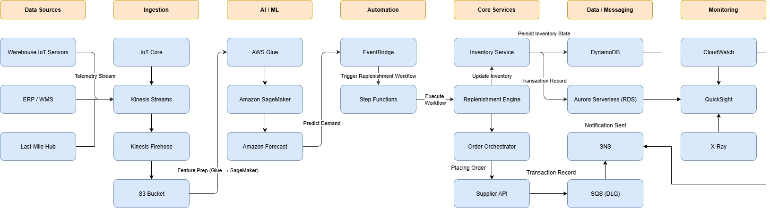

Runtime View (Scenario: Real-Time Replenishment Flow)
- Sensors and ERP systems stream real-time SKU updates into Kinesis.
- SageMaker Forecast model predicts near-term demand spikes.
- EventBridge triggers the Replenishment Workflow if stock < threshold.
- Step Functions invoke API calls to suppliers or alternate warehouses.
- Notifications sent via SNS to supply managers and dashboards updated.

Risks and Mitigations
Risk | Impact | Mitigation
Model drift under new market conditions | Forecast inaccuracy | Automated retraining via MLOps pipelines
Data latency from IoT sources | Stale inventory data | Use edge processing and Kinesis Data Firehose
Over-automation | Wrong restocking decisions | Introduce confidence thresholds and human-in-loop
Compliance risk | Legal exposure | Adhere to NIST AI RMF and GDPR

Architecture Decision Records (ADRs)
Decision | Justification | Trade-offs
Use AWS SageMaker for AI workloads | Managed ML service with scalable MLOps | Cost during idle time
EventBridge for orchestration | Simplifies workflow automation | Limited visual traceability
DynamoDB for stock tracking | Low latency, horizontal scale | Eventual consistency
Kinesis for streaming | Real-time throughput | Complex setup for multi-region sync

Conclusion
The proposed AI-driven architecture transforms traditional supply chain management into a predictive and autonomous ecosystem.
By combining real-time data ingestion, machine learning insights, and event-based automation, it ensures continuous inventory optimization even under extreme volatility.
The design prioritizes scalability, reliability, and explainability — ensuring that both business and operational teams can respond proactively to Black Friday’s unprecedented demand spikes.

